# CS 255 System Design Document Template

This template lays out all the different sections that you need to complete for Project Two. Each section has guidance to prompt your thinking. You will need to continually reference the interview transcript as you work to make sure that you are addressing your client’s needs. There is no required length for the final document. Instead the goal is to complete each section based on what your client’s needs are. Remove this note when you are finished, and replace all bracketed text with the relevant information.

## UML Diagrams

### UML Use Case Diagram

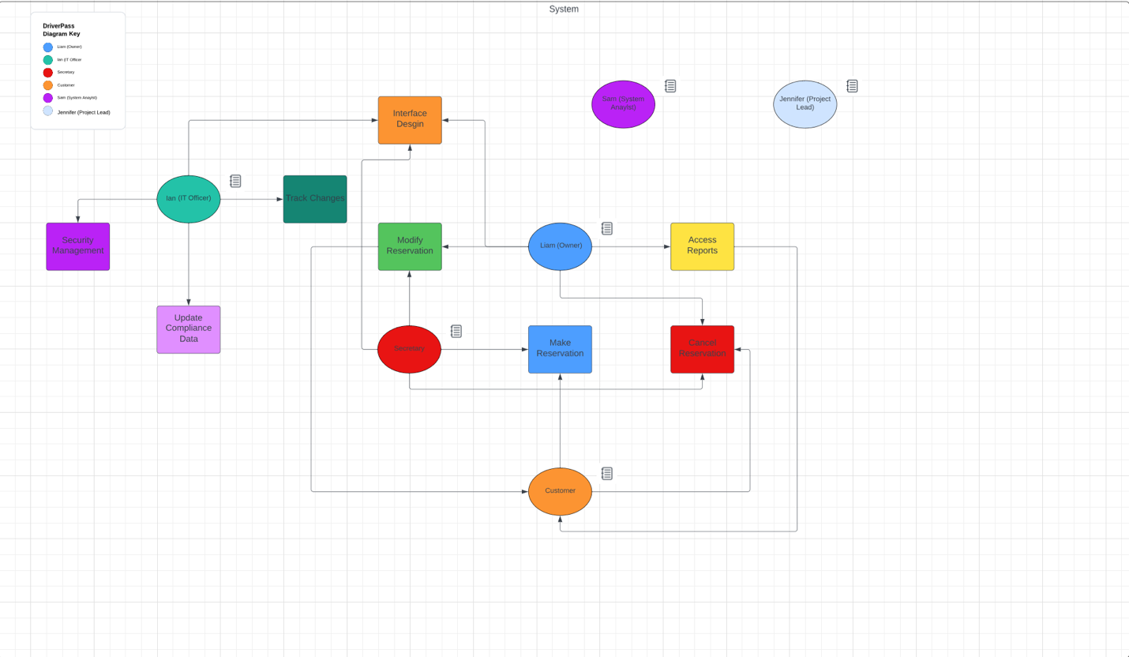

### UML Activity Diagrams

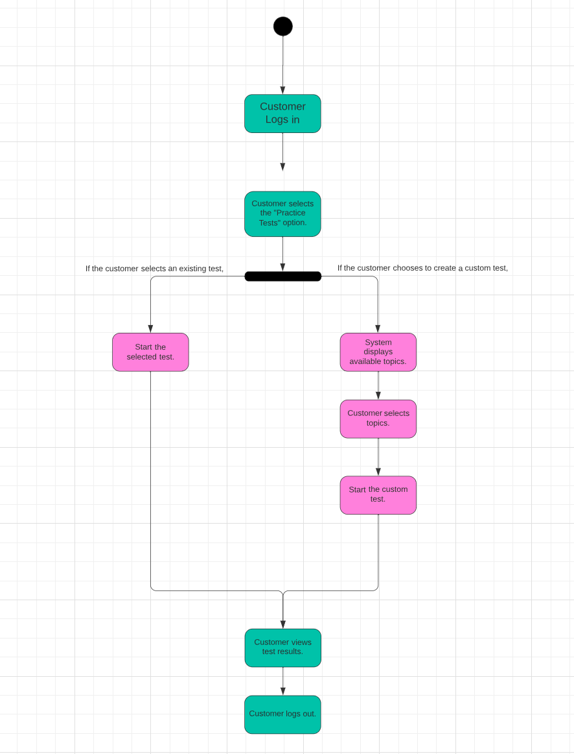

### UML Sequence Diagram

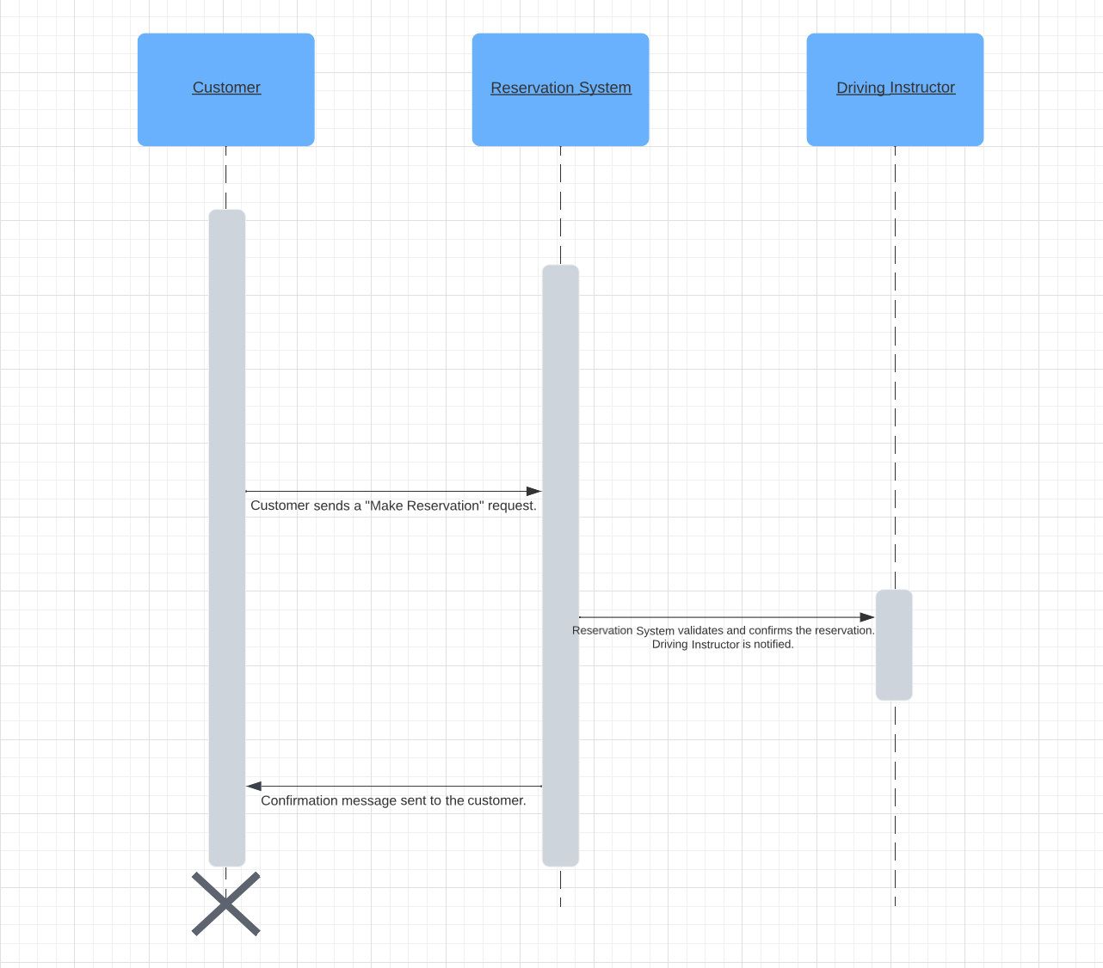

### UML Class Diagram

## Technical Requirements

1. **User Authentication and Authorization:**
   * **Technical Requirement:**
     + Use a secure authentication mechanism (e.g., OAuth, JWT).
     + Implement role-based access control (RBAC) to manage user privileges.
2. **Online Reservation System:**
   * **Technical Requirement:**
     + Develop a web-based system using a suitable web application framework.
     + Utilize a database management system to store and manage reservation data.
     + Implement a user-friendly interface for customers to make reservations.
3. **Practice Test Module:**
   * **Technical Requirement:**
     + Create an online practice test module with a database to store test questions and answers.
     + Develop a responsive and intuitive user interface for test-taking.
4. **User Data Management:**
   * **Technical Requirement:**
     + Use a relational database to store and manage user data.
     + Implement secure data transmission protocols for user data protection.
5. **Integration with DMV:**
   * **Technical Requirement:**
     + Establish an API or data exchange mechanism for real-time synchronization with the DMV database.
     + Implement automated notifications for updates from the DMV.

**Nonfunctional Requirements:**

1. **Scalability:**
   * **Technical Requirement:**
     + Host the system on a scalable cloud infrastructure (e.g., AWS, Azure) to handle potential increases in user traffic.
2. **Security:**
   * **Technical Requirement:**
     + Implement encryption protocols (e.g., SSL) to secure data transmission.
     + Utilize secure coding practices to prevent vulnerabilities.
3. **Availability:**
   * **Technical Requirement:**
     + Implement redundant servers and load balancing for high availability.
     + Set up regular backups and a disaster recovery plan.
4. **Performance:**
   * **Technical Requirement:**
     + Optimize database queries and use caching mechanisms for improved performance.
     + Implement monitoring tools to identify and address performance bottlenecks.
5. **Cross-Browser Compatibility:**
   * **Technical Requirement:**
     + Design and test the user interface to ensure compatibility with major web browsers (Chrome, Firefox, Safari, Edge).
6. **Usability:**
   * **Technical Requirement:**
     + Conduct usability testing during development to ensure an intuitive and user-friendly interface.
     + Implement responsive design for accessibility on various devices.
7. **Compliance with DMV Rules:**
   * **Technical Requirement:**
     + Establish a secure and reliable connection to the DMV database for compliance updates.
     + Implement a notification system for timely information dissemination.
8. **Data Backup and Recovery:**
   * **Technical Requirement:**
     + Set up automated data backup procedures.
     + Develop a data recovery plan to minimize downtime in case of system failures.